
Office of Prehospital Care: 562-933-1461
2801 Atlantic Ave Long Beach, CA 90806
Parking $8 – we do not validate parking
Prehospital Care Coordinator –Samantha Verga-Gates - Sverga-gates@memorialcare.org
Base Medical Director – Dr. Ray Sebastian

November 2026 bsm-fca 3 hours!!
Adult and pediatric trauma

Friday November 13, 2026 from 08:30 – 11:30
Location: LEAN Classroom (please check in at the main lobby info desk for directions)
Presentation by Brandon DiMiceli MSN, AGACNP-BC and Sydny Delgado-Kurth MPH, RN, PHN, MICN, CEN
EMS CE & BRN CE Provided!

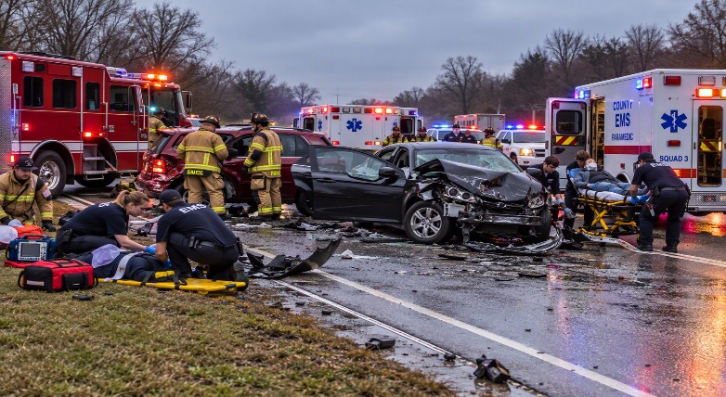

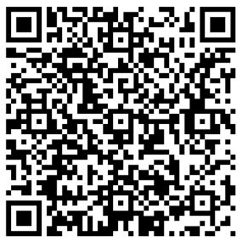
You MUST register via the QR Code. Class size is limited.
https://forms.cloud.microsoft/r/hJVAZhz2tM
**All CE is instructor based and approved for 3 hours of prehospital CE each by CA EMS CE provider #19-0032
"Provider Long Beach Memorial Medical Center approved by the California Board of Registered Nursing, Provider Number 512, for 3 contact hours"
Target audience: EMT, Paramedic, MICN, RN
*Objectives available upon request*

